# Scenario 2: Edit Project

## Scenario Description

* All functionality relating to editing a project

## Version Control

|  |  |  |  |
| --- | --- | --- | --- |
| Version # | Date | Author | Description |
| 1.0 | 21/08/2019 | Brodie Osborn | Initial Version |

## Test Scripts

The following scripts will cover this scenario:

* 1.1 Successfully edit Project

## Use Case

* Edit Project

## Test Components/Requirements

This test scenario covers the following high-level test requirements (see scripts below for specific requirements covered by each test script):

* Ensure that an existing project can have its details edited by an appropriate user
* Ensure that changes to the project are stored within the system properly

## User Groups

* Project ManagerScript 1.1: Successfully edit project

### Script Description

* A Project Manager is able to edit the requirements for a given project

### Testing Requirements

This test script covers the following specific testing requirements:

* Ensure that an existing project can have its details edited by an appropriate user
* Ensure that changes to the project are stored within the system properly

### Setup

* Test Project 1 (Manhattan Project) must exist within the system

### Teardown

* None

### Script Steps

| **Step #** | **Test Action** | **Expected Results** | **Pass/ Fail** |
| --- | --- | --- | --- |
| 1 | Click “Manage Projects” Button | Open Projects Page | PASS |
| 2 | Click “Edit Project” Button | Open Project window | PASS |
| 3 | Enter a new Java requirement into the requirements list for the project  Click the “Save” button | Save changes to Project  User is returned to the Project screen | PASS |

### Test Execution

|  |  |  |  |  |
| --- | --- | --- | --- | --- |
| Date/Time | Tester | Test ID | Test Phase | Status |
| 08/09/2019 | Brodie Osborn | #1 | In Development testing | Testing Complete |

## Screenshots

Before

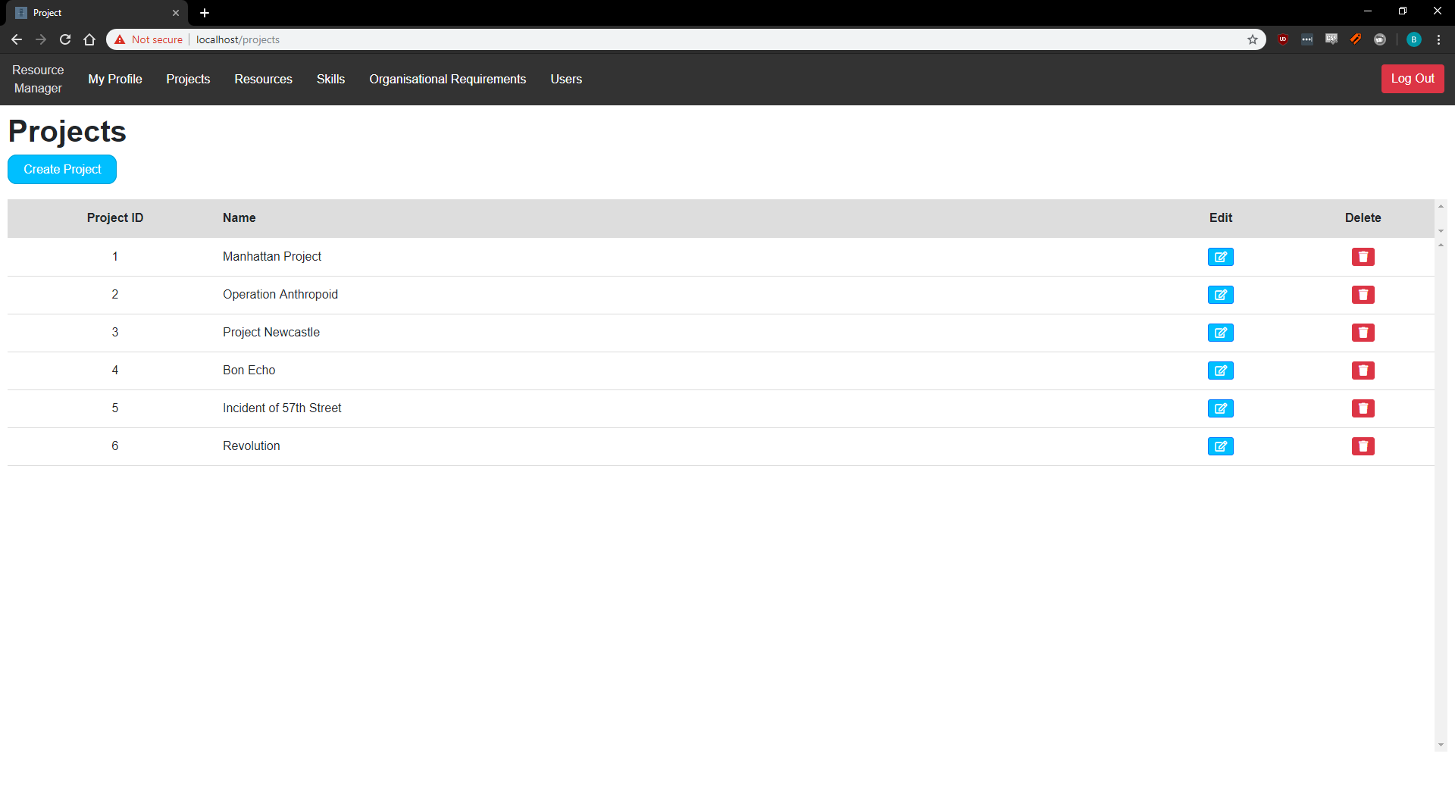

Step 2

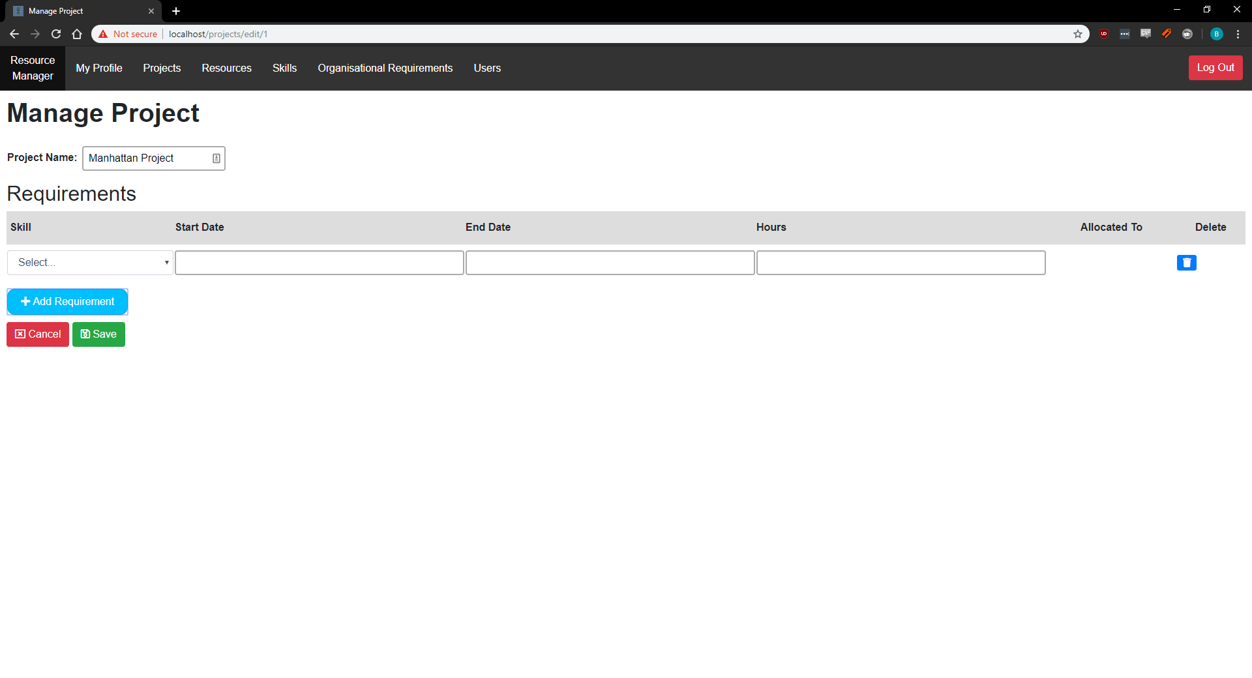

Step 3

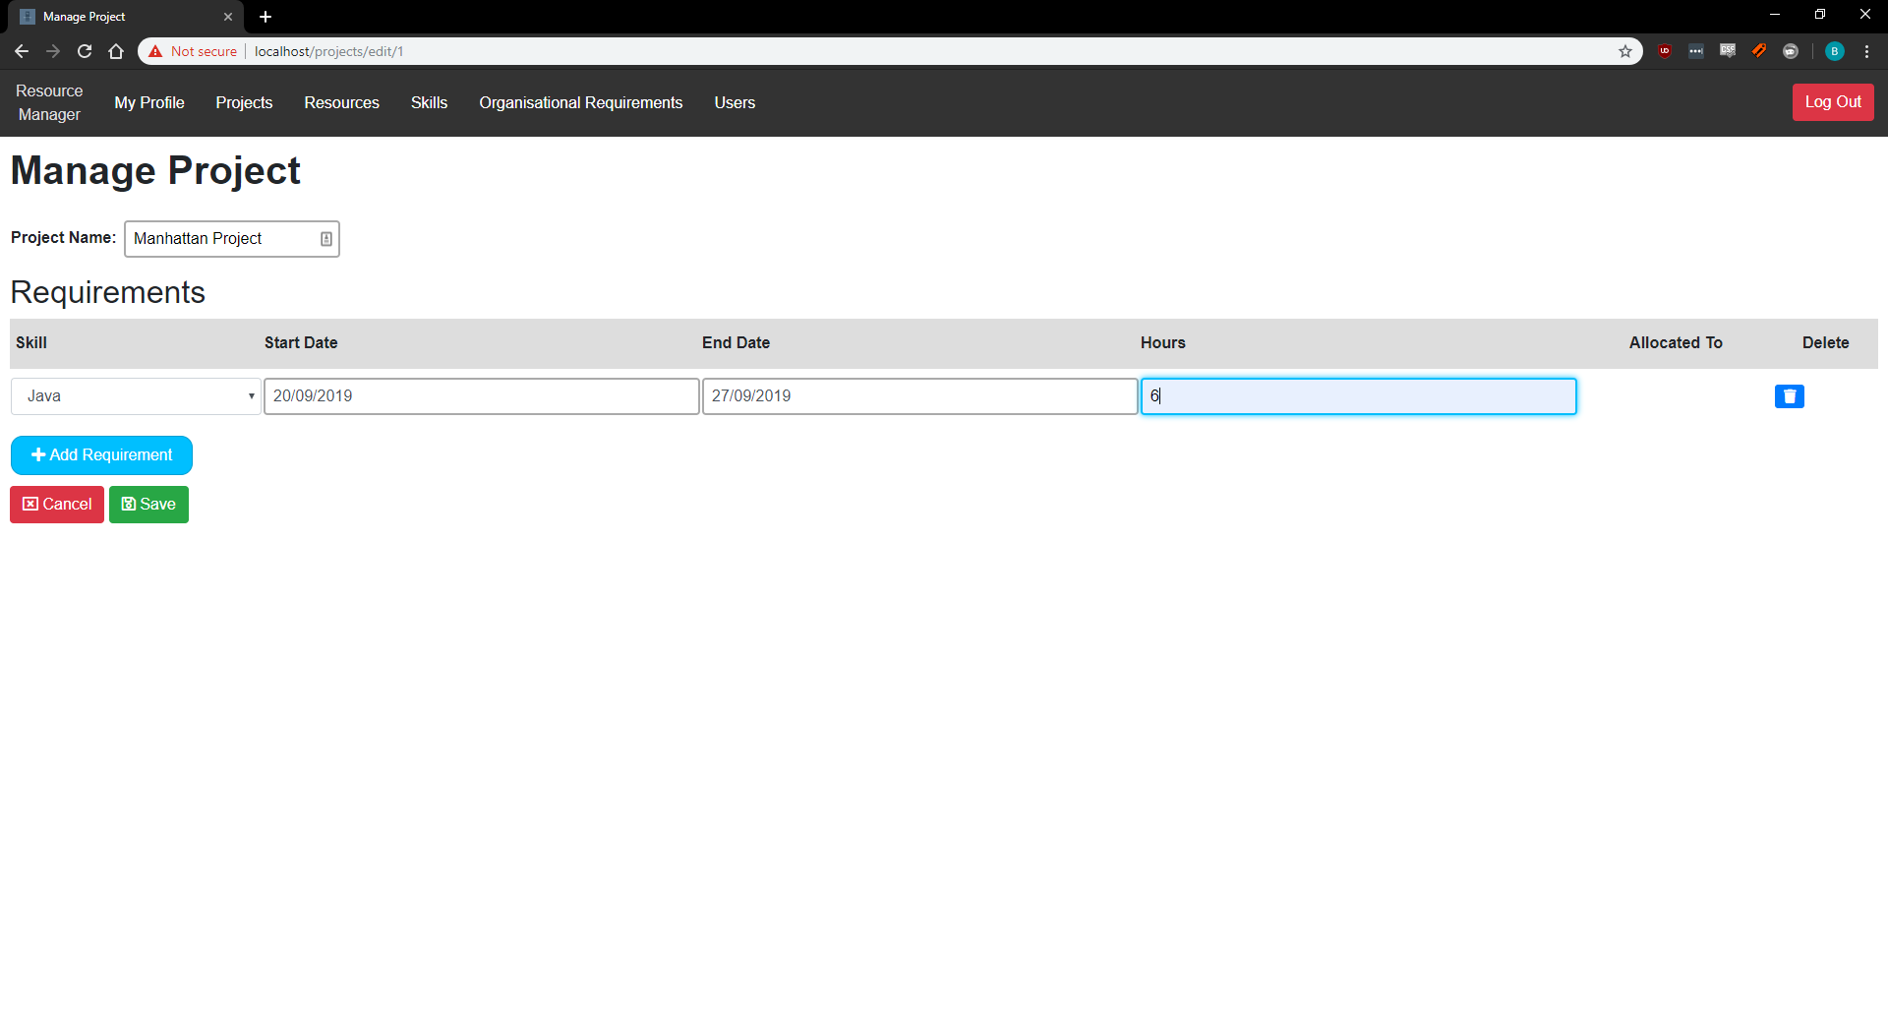

After

